
ENEL4CB – Computer engineering design project
Project title: Vitality Watchdog System
Phase 1 report
Prepared by Orien S. Harichand (222012115)
GA assessment table:
GA | ECSA definition | Implementation | Status
1 - Problem solving | Identify, formulate, analyse, solve CEP | Researching and identifying a CEP that falls under my topic, while providing an acceptable solution and discussing other available options according to the literature sourced. | GREEN
2 - Application of scientific and engineering knowledge | Apply knowledge of math, natural science, engineering  fundamentals and an engineering speciality to solve CEP | Heavy research into Cardiac and respiratory health, and application of embedded system design as well as research into and application of signal processing techniques; and design decision undertaken based on these areas together with the application of software engineering knowledge (cross-platform support) so that a complete end-to end system can be developed. | BLACK
3 - Engineering design | Perform creative, procedural and non-procedural design and synthesis of components, systems,  engineering works, products and processes | Software engineering and OOP principles used for the creation of the companion app, API creation for the app to communicate with the target device and signal processing conducted on data transmitted from the target device. | RED
6 - Professional and technical communication | Communicate effectively in oral and written mediums with engineering  audiences and community | Creation, editing and review of design report documents to be submitted for phases 1, 2 and 3 of this module, along with ppt presentations to be made, demos to be performed and presentations to be held. | BLACK
Project focuses:
Area/Field | Weight in project (%)
Biomedical engineering and  Instrumentation | 20
Computer Vision, Signal and Image  processing | 10
Embedded systems, IoT and edge  computing | 50

Abstract
People may experience cardiac issues without ever feeling it or may feel it so much that it renders them unable to call out for assistance. Wearable healthcare devices have come a long way in recent years, enabling users to measure their vital signs such as heart rates, respiratory rates, heart rate variability, stress etc., provide insights into their health trends and patterns, notify them when they exhibit worrisome vital signs and even contact other people by utilizing the connection to the user’s smartphone, yet there lacks a device that can provide continuous monitoring AND assist the user in alerting others if they exhibit worrisome signs and require help but are unable to do so. This report explores the development of such a system that provides continuous detection of vital signs and determines if any anomalies are present, before alerting the user of these anomalies but also sending remote notifications to selected contacts should the user be in severe imminent danger and is unable to call for assistance themselves. The proposed system utilizes the photoplethysmography technique for detection of vital signs, signal processing algorithms for extraction of various health metrics from the PPG signal and a companion application on the user’s smartphone to handle the alerting functionality. Due to time constraints of the project, only the utmost vital aspects will be focused on first – heart rate monitoring, anomaly detection and alerting functionality, and if time permits it then attempts will be made to extract other signals, namely respiratory rates and heart rate variability.

Table of Contents
Abstract ii
Introduction 1
Problem identification 1
Project details 2
Objectives 2
Conceptual block diagram 2
Functional block diagram 2
Literature survey 2
Requirements analysis 4
Specifications 4
Constraints 4
Assumptions 5
Feasibility study 5
Conclusion 5
References 6
Appendix 7

Introduction
People often don’t feel the severity of stress and cardiac issues and pass off some symptoms that could indicate cardiac issues (such as prolonged rapid/slow heart rates) as nothing to worry about. People experiencing severe and sudden cardiac issues such as heart attacks may have trouble calling for help and alerting others during the period of distress. Both issues can have severe impacts on a person’s health and may even lead to permanent damage should timely intervention not occur.
This could be mitigated/lessened if the person had a way of automatically notifying themselves/others if they are in danger (such as when their heart rate (HR)/respiratory rate (RR) is too high/low) so that immediate action/measures can be taken to assist the person.

Problem identification
Currently, there exists very few wearable solutions that automatically detect and measure a user’s vital signs continuously and notifies others if the user is in imminent danger. These also cost far too much for the average person to afford, such as the Polar H10 (~R1800) [1], Google Fitbit Versa 4 (~R3000) [2], Garmin Vivosmart 5 (~R2500) [3], Wellue O2Ring (~R3000) [4] and Hume Band (~R4600) [5], and others that exists feature subscription-based models to unlock the full benefits of the device – the Whoop band (~R6000/year for full benefits). Furthermore, some of the solutions that exist are bulky (the Wellue O2Ring) and can inconvenience/discomfort the user during long-term wear.
This highlights the need for the development of a device that can perform the functions of a wearable vital-signs monitor – continuously detecting heart rates, respiratory rates in a non-invasive manner [6] so that if a user’s heart is beating dangerously fast, or their breathing temporarily stops (indicating potential obstructive sleep apnea (OSA) [7] [8]), others have a way of knowing about it and can intervene to provide assistance. Real-time measurement and quick response times are needed to ensure that alerts are sent out as soon as a person is determined to be in danger and edge cases need to be handled – which calls for robust embedded system design.
Determining the condition/status of the heart requires an in-dept knowledge and heavy research into the heart, how it functions and how to interpret a heart rate signal, with similar levels of knowledge required to understand and interpret respiratory rate [7] signals. These signals also require processing to mitigate external influences on signal measurement. High-end sensors come with high-end prices – therefore to make the device affordable for the average person, accuracy needs to be balanced with the cost of sensors used in the device. To ensure the system can be utilized to its full extent by any user, a companion application needs to be developed that has cross-platform compatibility.

Project details

Objectives
The purpose of this project is to design and build a system capable of continuous automatic vital sign measurement under stringent budgetary, battery capacity and time constraints that can inform the user and others nearby if the user is in danger so that timely measures can be taken to assist the user. The device needs to act as a cheaper alternative to similar devices on the market and must be comfortable for the user to wear for long periods of time.
The system should enable a user to view some of their health data while also enabling remote notifications to selected contacts during periods of distress.

Conceptual block diagram
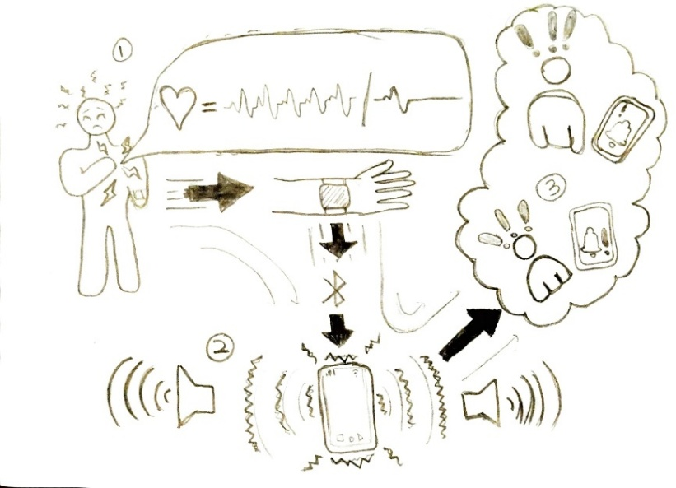
Figure 1 conceptual block diagram showing the system in operation

Functional block diagram
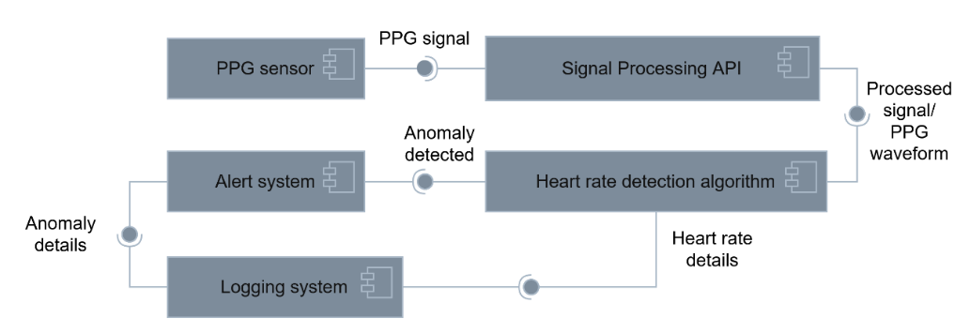
Figure 2 component diagram showing the interaction between system components

Literature survey
Multiple methods of monitoring vital signs have emerged over the years which fall into two distinct categories – contact and non-contact. Yong et al. [6] provides a comprehensive comparison of multiple techniques that were developed under both methods, Molinaro et al. [9] provides a non-contact technique of measuring that involves processing videos recorded with digital cameras and Abuella and Ekin[10] presents a non-contact monitoring system that measures vital signs using visible light sensing technology. Considering all techniques covered by this literature, it was determined that all non-contact methods, while performing well to measure vital signs accurately, are unviable to utilize in this project as they are neither portable solutions nor ones that can be implemented by an average person. Invasive techniques, due to their nature, are also unviable. The remaining non-invasive methods presented were heart auscultation (via phonocardiograms (PCG) and common blood pressure (BP) measurement), ballistocardiography (BCG), photoplethysmogram (PPG) and electrocardiogram (ECG).
PCG measures the acoustic activity of the heart via a microphone placed on the chest [11], [12]. BP measurements utilize an inflatable cuff placed on the upper arm to generate pressure waveform signals[13]. BCG measures the body’s repetitive motion when the heart ejects blood into blood vessels [14]. PPG utilizes light to determine the blood volume in vessels by measuring light reflected off the capillary bed [15]. ECG measures the electric impulses generated by the heart, traditionally requiring multiple leads to be placed around the chest area, but can also be done with one lead [12].
PCG holds the second-lowest accuracy and is very easily influenced by acoustic interference. BP measuring improves on this accuracy, but its cuff size and operating mechanics limit its portability and long-term use. BCG is extremely susceptible to body movement and noise and claims the lowest accuracy. PPG has the second-highest overall accuracy but can be heavily influenced by ambient light, skin tones and skin temperature. ECG has the best accuracy using the traditional 12-lead implementation however this accuracy drops greatly as the number of leads decrease. In addition, continuous monitoring is only possible when using multiple leads, as, if only one were used (like in most smartwatch-style wearables), the user would be required to touch the device with one limb while it is in contact with another to enable measuring. [6], [10], [12]
Based on this, PCG, BP and BCG are not suitable for field use. This project is to be implemented in the field and the technique that provides the best balance between accuracy and interference is PPG. The ECG technique, while having great accuracy, fails at providing continuous automatic monitoring with a single lead and while this can be solved by using multiple leads, this implementation is not suitable for long term use, and its wearability and comfortability is limited. PPG shows the most versatility by allowing placement anywhere on the arm/forearm, with a form factor similar to that of a watch/wristband, ensuring that it does not impede the user’s movement and causing the least discomfort with long-term use as compared to an ECG implementation. Influences such as skin tones and motion artifact can be minimized by using filtering and good pre-processing techniques and detection algorithms [15], and, because of its optical measurement nature, the device it’s used in can be built to be waterproof.

Requirements analysis
Table 1 Requirements analysis table
Functional requirements | Non-functional requirements
The user is alarmed/alerted when anomalous signals are detected | The system must be comfortable to wear
Remote alerts get sent when severe anomalous signal detected | The system must be easy to operate
The system must have quick response times | The system must be easy to wear/dislodge
Automatic continuous monitoring of vital signs | The companion app should be intuitive/easy to navigate
The system must be affordable
Accurate measurements must be made
The battery should be used efficiently
The application must be able to work on different devices
The system must determine if there are anomalies in the vital signs measured

Specifications
Table 2 Specifications table based on MSCW framework
Must have | - Heart rate monitoring  - Audible and vibratory alerts that occur when anomalous signals are detected  - Anomaly detection
Should have | - Push notifications to selected contacts when severe anomalous signals are detected  - High sampling frequency so that important portions of the signal waveform are not skipped  - Low end-to-end system latency
Could have | - Battery optimization techniques  - Cross-platform compatible application  - Respiratory rate monitoring  - HRV monitoring
Won’t have | - Diagnosis of any disease/condition  - Functionality to make/manage phone calls  - Generic smartwatch functionality

Constraints
This project is influenced by budgetary constraints of R2500, time constraints of 9 weeks, the battery capacity and device size impact comfort and capabilities of the. The system does not diagnose specific heart/respiratory diseases or conditions except for possible heart attacks.

Assumptions
The user owns a modern smartphone that has Bluetooth and messaging capabilities and has a WiFi connection or enough mobile data and/or airtime on their phone such that a message can be sent out from their phone successfully.

Feasibility study
Several traditional and modern methods of processing ppg signals exist, with modern methods leveraging machine learning models to achieve predictive capabilities and higher accuracies than traditional methods [15], but since this project requires real-time measurements and feedback while minimizing computational overhead, using a model would not be suitable. The project overall is technically feasible, as devices currently exist that perform similar detection and analysis of vital signs via the use of PPG.
Analysing the PPG signal can lead to the extraction of 4 major waveforms: Heart Rate, Respiratory Rate, SpO2 and Heart Rate Variability (HRV). Due to the time constraints of the project the successful extraction of all may not be possible, therefore this project will focus on extracting the heart rate waveform, and if time permits it then extraction of the other waveforms will also be conducted and a combined analysis will be attempted in order to better detect anomalies. Additionally, due to the time constraints, a minimum viable product is considered to be a system that successfully detects a PPG signal and extracts a heart rate signal, determines if anomalies are found with the heart rate and audibly alerts the user if the anomalies are considered severe, followed by remote push notifications to selected contacts.
The financial feasibility of this project is heavily influenced by the budget and the cost of highly accurate sensors and potential hardware required for raw signal preprocessing[15]. To reduce hardware costs, signal processing itself is offloaded from the device and onto an API on the user’s smartphone.

Conclusion
The development of a wearable auto-alert system when a person’s vital signs go beyond safe thresholds shows considerable promise, as devices that contain these two functions currently exist separately, and with dedicated non-wearable solutions existing in the medical field. Multiple techniques exist for detecting the vital signs of a person, of which the best were determined to be ECG and PPG when system mobility is desired, and PPG is the better of the two for an arm/hand-based device, with ECG dominating chest-worn devices. Although PPG can experience interference that moderately affects monitoring, methods exist that can lessen the effect of this interference and undesirable noise via simple preprocessing and good detection algorithm design. Time feasibility is expected to have the greatest impact on the project when compared to the feasibility factors, but by focusing on the core aspects mentioned, this project can be completed during the allocated time.

References
[1] “Polar H10 | Polar USA.” Accessed: Jul. 23, 2026. [Online]. Available: https://www.polar.com/us-en/sensors/h10-heart-rate-sensor
[2] “Amazon.com: Fitbit Versa 4 Fitness Smartwatch with Daily Readiness - 3-Month Google Health Premium Membership Included - GPS, 24/7 Heart Rate, 40+ Exercise Modes, Sleep Tracking - Waterfall Blue/Platinum, : Electronics.” Accessed: Jul. 26, 2026. [Online]. Available: https://www.amazon.com/dp/B0B4MZWCXK/?rvo_aff=1&rvo_brandid=Fitbit&rvo_prodid=873ee0c7-8da7-4a01-8a17-c77258ffafd0&rvo_subid=873ee0c7-8da7-4a01-8a17-c77258ffafd0&tag=healthline-subtag-20&rvo_subid2=%2Fnutrition%2Fbest-heart-rate-monitoring-watch&ascsubtag=61ba2731-3013-4723-8b7d-3d0ee8864334&correlationId=61ba2731-3013-4723-8b7d-3d0ee8864334&th=1
[3] Garmin and G. L. or its subsidiaries, “vívosmart® 5,” Garmin. Accessed: Jul. 26, 2026. [Online]. Available: https://www.garmin.com/en-US/p/782585/pn/010-02645-00/
[4] “Wellue O2Ring Smart Ring Pulse Oximeter. Overnight Tracking.,” Wellue. Accessed: Jul. 06, 2026. [Online]. Available: https://getwellue.com/pages/o2ring-oxygen-monitor
[5] “Hume Health Band | Advanced Wearable for Better Health Tracking,” Hume Health. Accessed: May 13, 2026. [Online]. Available: https://humehealth.com/pages/hume-band
[6] Q. Yong, L. Yang, A. Kardos, and Y. Zhao, “Non-invasive cardiovascular and vital signs monitoring techniques: review, challenges, and perspectives,” Measurement, vol. 258, p. 119472, Jan. 2026, doi: 10.1016/j.measurement.2025.119472.
[7] J. Landry, BS, and RRT, “Abnormal Breathing Patterns: Types and What They Mean (2026),” Respiratory Therapy Zone. Accessed: Jul. 17, 2026. [Online]. Available: https://www.respiratorytherapyzone.com/breathing-patterns/
[8] J. Lázaro et al., “Pulse photoplethysmography derived respiration for obstructive sleep apnea detection,” in 2017 Computing in Cardiology (CinC), Sep. 2017, pp. 1–4. doi: 10.22489/CinC.2017.273-229.
[9] N. Molinaro et al., “Contactless Vital Signs Monitoring From Videos Recorded With Digital Cameras: An Overview,” Front. Physiol., vol. 13, p. 801709, Feb. 2022, doi: 10.3389/fphys.2022.801709.
[10] H. Abuella and S. Ekin, “Non-Contact Vital Signs Monitoring Through Visible Light Sensing,” IEEE Sensors J., vol. 20, no. 7, pp. 3859–3870, Apr. 2020, doi: 10.1109/JSEN.2019.2960194.
[11] E. Delgado-Trejos, A. F. Quiceno-Manrique, J. I. Godino-Llorente, M. Blanco-Velasco, and G. Castellanos-Dominguez, “Digital Auscultation Analysis for Heart Murmur Detection,” Ann Biomed Eng, vol. 37, no. 2, pp. 337–353, Feb. 2009, doi: 10.1007/s10439-008-9611-z.
[12] J. Nedoma et al., “Comparison of BCG, PCG and ECG signals in application of heart rate monitoring of the human body,” in 2017 40th International Conference on Telecommunications and Signal Processing (TSP), Jul. 2017, pp. 420–424. doi: 10.1109/TSP.2017.8076019.
[13] J. E. Sharman et al., “Automated ‘oscillometric’ blood pressure measuring devices: how they work and what they measure,” J Hum Hypertens, vol. 37, no. 2, pp. 93–100, Feb. 2023, doi: 10.1038/s41371-022-00693-x.
[14] S. K. Jose, C. M. Shambharkar, and J. Chunkath, “Cardiac arrhythmia detection using ballistocardiogram signal,” in 2015 IEEE International Conference on Signal Processing, Informatics, Communication and Energy Systems (SPICES), Feb. 2015, pp. 1–5. doi: 10.1109/SPICES.2015.7091531.
[15] J. Park, H. S. Seok, S.-S. Kim, and H. Shin, “Photoplethysmogram Analysis and Applications: An Integrative Review,” Front. Physiol., vol. 12, Mar. 2022, doi: 10.3389/fphys.2021.808451.

Appendix
Work plan
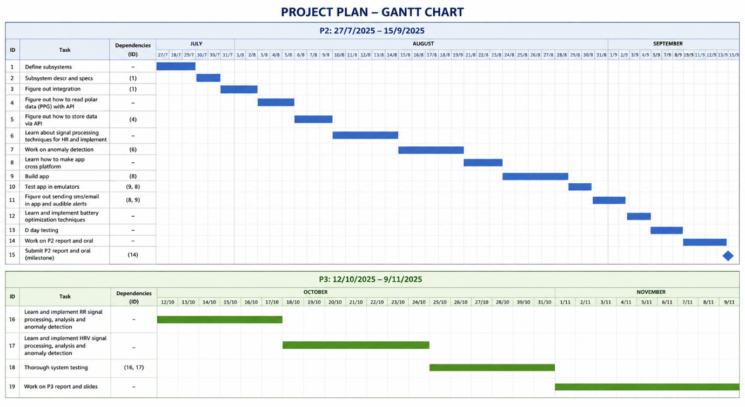
Figure 3 Gaant chart showing my work plan over the next 5 months

